

EBAY CONTROLLER TEST DATA SHEET

P/N: 414-8005-95 Date: 15/04/2018

S/N: -1 Time: 17:48

UA: 95 Tested by: Nissim

Hardware Rev: BLDC_60A_V6 Approved by: Nissim

Software Rev:

Tester Software Version: 1.2k

Equipments Used

Equipments Model No Serial No

Power Supply

Digital Multimeter

CAN Interface

BLDC Tester

PC

Heater

RS-232 Interface

Current Meter

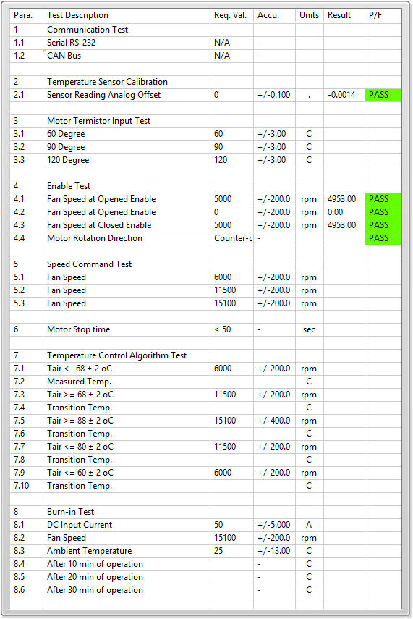

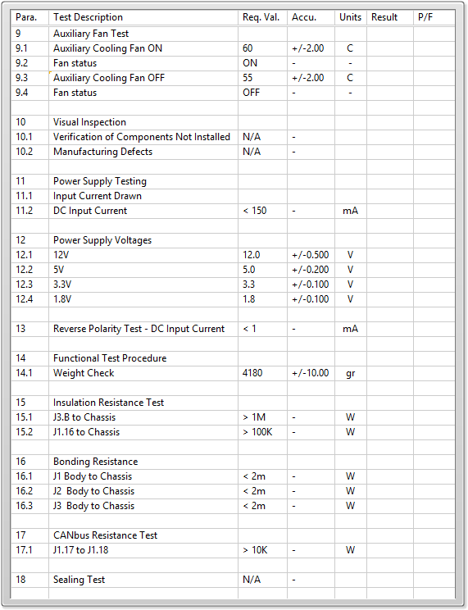

General result:

Test-Operator:____ Nissim_________ Q.A.:__________________________